UNIVERSITY OF NEW MEXICO

System Requirements Specification

For The
Collaborative Solar Image Annotation
Prepared For:
Professor Marios S. Pattichis
pattichis@gmail.com
Director, image and video Processing and Communications Lab
Chair, Computer Engineering Program
Dept of ECE, UNM
www.ivpcl.org
and
AFRL Space Weather Center of Excellence
Dr. Nick Arge
Dr. Carl Henney
Dr. Rachel Hock

Prepared by:
ECE 435 Fall Semester Project Team
DATE TBD
Revision 2
Table of Contents
1. Introduction 1
1.1 Purpose 1
1.2 Product Scope 1
1.3 References 1
2. Overall Description 1
2.1 Product Perspective 1
2.2 Product Functions 2
2.3 User Definition 2
2.4 Operating Environment 2
2.5 Design and Implementation Constraints 2
2.6 User Documentation 3
2.7 Assumptions and Dependencies 3
3. External Interface Requirements 3
3.1 User Interfaces 3
3.2 Hardware Interfaces 4
3.3 Software Interfaces 5
3.4 Communications Interfaces 5
4. System Features 6
4.1 Image Retrieval and Annotation 6
4.2 Multi-Platform Deployable 6
4.3 Multi-User Interface 7
4.4 Upload Images 7
4.5 SDO/AFRL Compliant Exportable Format 8
4.6 Collaboration on Images 9
4.7 Communication Among Users 9
5. Other Nonfunctional Requirements 10
5.1 Performance Requirements 10
5.2 Safety Requirements 10
5.3 Security Requirements 10
5.4 Software Quality Attributes 10
5.5 Business Rules 10
Appendix A: Glossary 11
Appendix B: Acronyms 12
Appendix C: Data Flow Diagram 13
Appendix E: Dashboard GUI View 15
Appendix F: Subsystem Decomposition Diagram 16
Appendix G: Database Entity-Relationship Diagram 17
Revision History
Version | Reason For Changes | Date
1 | Initial Release | 23-OCT-2104
2 | Addressed Action Items from Presentation of SRS on 23-OCT-2014.  Added Canvas and HTML5 compatibility in Section 3.3.7. Revised System Decomposition Diagram Appendix F.  Revised database description with the addition of a Database Entity-Relationship Diagram in Appendix G.  Added Picture-in-picture zoom around mouse in Section 3.1.2.c.  Added lines connecting annotations in Section 3.1.2.e.  Added date-time stamp of image visible at all times in Section 3.1.2.f.  Added User can annotate two different bandwidth observations of the same picture in Section 3.1.2.d.  Updated design concept of GUI to show “logout” in dashboard in Appendix E.  Clarified for commercial use and for research use in Section 5.5. | 6-NOV-2014

Introduction

Purpose
The objective of this project is to provide a collaborative internet application (web app) in which users will be able to annotate solar observational images. Users will use a mouse to click along the perimeter of coronal holes in the images. The annotated data will be joined with its respective image and made available for further analysis by the image provider.

The motivation driving the project purpose cited by the sponsor are concerns of space weather generated by solar activity and its impacts which can cause significant damage to spacecraft operations, critical satellite operates like GPS, astronauts, radio communications and the power grid. The data from this project will also improve space weather prediction capabilities.

Product Scope
This solar image annotation software will be capable of running on an open-source web server. The web app will retrieve solar images from the Solar Dynamics Observatory website and then allow users to annotate coronal holes on images. Multiple users will be managed and supported, and collaboration among the users will be allowed. Software will consist of PHP, MySQL, JavaScript, HTML and CSS only.

References
A presentation by the sponsor, Professor Marios S. Pattichis, was given on the 18th of September 2014 in order to promote this project for development. The presentation slides describe general project requirements, specify software components and recommend the book “Learning PHP, MySQL, JavaScript, CSS & HTML5: A Step-by-Step Guide to Creating Dynamic Websites”, June 2014 by Robin Nixon. In addition, the presentation covered the motivation for the project, names of AFRL Space Weather Center of Excellence co-sponsors and why the sponsors are interested in promoting this project to UNM students.

Overall Description

Product Perspective
The solar annotation web app is a follow-up to a similar existing Linux application. This web application will have similar general functionality; users will be able to view images, mouse-click on coordinates and store their position in the database. However, this is a completely new standalone program, written from the ground-up with web technologies in mind. Our web app has more features than the original Linux application, users can collaborate on images and the solar image download process is completely automated.

Product Functions
The first major function is that users must be able to make an account and log into the site where they can view their solar annotation data. Administrative users need to have the ability to see all user annotation data, with the ability to easily download and export this data.

The web app has to be able to pull the latest solar image, convert it from FITS to the necessary compressed image format, likely PNG.

For annotating images users will need to have the ability to click on screen, make waypoints that are stored in a coordinate form with the top left of the image being (0,0) and the bottom right of the image being (1,1).

On the backend the web app needs a MySQL database. In this database user information such as first name, last names, passwords, image information, and coordinates.

User Definition
Types of users will consist of administrators and regular users. Regular users will have the ability collaborate with other users and annotate solar images. Administrators will also have the ability to annotate solar images and collaborate, but they will also have the ability to view all other coronal solar annotations from other users and save/download annotation output to a CSV file (annotation data can be pulled from the MySQL database).

Operating Environment
The operating environment will consist of an x86_64 Linux web server running either Red Hat Enterprise, CentOS, Ubuntu Server, or Debian. Options for the operating system depend on where the website is hosted. Software will be a full LAMP Stack including Linux, Apache, MySQL, PHP, JavaScript, and CSS. Various web browsers with different versions will be needed for testing on the client side including: Internet Explorer, Firefox, Google Chrome, and Safari.

Design and Implementation Constraints
As mentioned briefly above the design of the web application is limited to the use of HTML5 or previous versions, CSS, PHP, MySQL, and JavaScript. Web page formatting can be in either HTML or JSON. All code produced including client and server side scripting will be considered the “deliverables” of the project and be open-source. Application layer protocols used between the web application and server will be the standard HTTP and HTTPS protocols for distributed information systems.

The images retrieved from the Solar Dynamics Observatory (SDO) website are not under copyright and are available for non-commercial use and educational purposes. The images can be reformatted into different image formats of various resolutions as necessary for use with the web application. A format of PNG was suggested but not required for use with the web application. The only built-in security will be user account access. A visitor to the site may view but not modify or collaborate with other analysts or participate in forums unless they have established a user account and successfully logged into the application.

User Documentation
Basic instructions on how to use the web app will be provided in a help section on the site. Additional help can be found within a thread on the forum.

Assumptions and Dependencies
Our solar image web app will be easily deployed and ran on open-source platforms, i.e. the web app will not need proprietary software in order to function properly. The application will be compatible with most modern, relatively up-to-date web browsers (Chrome, Firefox, Safari, and Internet Explorer). Accurate retrieval of solar images needed for annotation will depend on NASA's SDO website.

External Interface Requirements

User Interfaces
The CARINA (CollAboRative Image aNnotAtion) webapp will consist of the following GUI components (see Figure in Appendix E) to allows users to interact with the software:

Menu Bar
Windows type commands
  - File - For uploading and browsing images.
  - Edit - Copy and paste annotations.
  - View - Edit the layout of the app to user preference. Zoom in/out on images.
  - Tools - Image filters and options for changing image color.
  - Login - Users can login – If not logged in.
  - Logout – A logout button that will sign out the user and close their session with the application.
  - Help - User manuals on running the application.

Loaded Image Filename Applet
Will display the current loaded image and user annotations.
  - Mouse-over cross hairs will designate areas of the image users can annotate.
  - Mouse positions x and y coordinates will be displayed at bottom of applet.
  - The image will “zoom-in” in the area around the mouse cursor, so the user can more easily see the area to annotate.
  - If the image is uploaded in different wave spectrums, these different versions of the image can be displayed side-by-side in the viewer.
  - Users will be able to connect annotation dots with lines in the app.
  - The date of the image is visible at all times.

Browse Images and Annotation Viewer
Will display browsed images and user annotations.
  - Users can browse images through list displayed in browser or by using arrows (yellow) to scroll through images.
  - Once a user is browsing an image, they can Browse Annotations for that image from other users by using the arrows.

Image Information
Image information that will be stored in the database and provided for the user are: resolution (pixels), scale, origin (user who uploaded the image), and the date that the image was taken.

Browse Images button
A grid showing all uploaded images available to annotate.

Load Image button
Loads image displayed in browser into Loaded Image Filename applet.
Since images are not pulled automatically, images to be annotated are uploaded by users.

Browse Annotations button
Displays a drop down list of user annotations.

Load annotations button
Adds annotations displayed in Browsed Images applet into Loaded Image Filename applet.

Save Annotations button
Saves all annotations in Loaded Image Filename applet to user database.

Hardware Interfaces
The user will interact with the app using a mouse and keyboard. This app does not support touch screen monitors.

Mouse
Left button will be used to select items. Right button will be used to open menu.

Keyboard
The app will support English standard QWERTY keyboard layouts. Arrow keys on the keyboard can be used to move the x,y cross-hairs on the image to be annotated. The space key can be used to apply or remove a waypoint on the image, (instead of clicking).

Software Interfaces
The CARINA webapp will interface with the following software components:

MySQL
The MySQL database will be the core of the webapp. The database will store user account information, like user-names. Since it is generally bad practice and not well advised to store the image files themselves in the database, we will most likely have variables that represent the images. The coordinates of the image annotations will be store in the database. Other variables to tie everything together will also be in the database.

Apache
The webapp doesn't have to pull images automatically; images for annotations are uploaded by users. Apache will be used by the webapp as the web server running the program and providing the content to the users.

JavaScript
JavaScript will be used to build the graphical front-end of the application.

Linux
Development of the web app will take place across different platforms, but in the end the application needs to be able to run on a Linux web server with Apache, MySQL, PHP, and JavaScript.

PHP
PHP will be used to interface between the information in the MySQL database and the HTML and JavaScript front end of the web application.

CSS
CSS in conjunction with JavaScript will be used to build the graphical front end.

HTML5 and Canvas
HTML5 and Canvas will be used heavily. The usage of Canvas will depend on browser support for Canvas

Communications Interfaces
The CARINA webapp will be accessible using HTTP and HTTPS and will utilize RSA encryption and SSL.

System Features

Image Retrieval and Annotation

Description and Priority
The user will be able to select from the most recent AIA and HMI images of various color filters using data access method described on the SDO website. Image previews are stored in a table along with a unique file name and date-time stamp. The image previews will be thumbnails, large enough and with just enough detail to give the user and idea of what the larger full resolution image will look like.

Stimulus/Response Sequences
- The user selects an image from the table.
- A full resolution version of the image is resized and appears in the viewable area.
- The user can use a zoom function to find an area to annotate.
- On mouse over the cursor will change to a crosshair mouse cursor for accuracy.
- The user can then plot points on the image, a symbol representing the plotted point will appear on the image.
- The X and Y coordinates will be shown on the screen in real time while the mouse cursor is over the image.
- When the user saves the annotations the X and Y coordinates of every plotted point will be stored in a database along with the user name, date, and time.

Functional Requirements
REQ-1: The image selected must be a valid link to the full resolution image. If the link is no longer valid an appropriate error message will be displayed to the user.
REQ-2: There must be a minimum of one point plotted on the image. If there are no points plotted the image will not save.
REQ-3 Any point plotted on the image is considered a valid point.
REQ-4 The user must be signed in to the web app before any image can be retrieved and annotated.

Multi-Platform Deployable

Description and Priority
The CARINA web app will be available for deployment in current Mac OS X, Windows, and Linux distributions as well as be accessible through various web browsers, including but not limited to Google Chrome, Mozilla Firefox, and Internet Explorer. The server will reside in the UNM ECE server, and will be tested for compatibility.

Stimulus/Response Sequences
      - The CARINA server will be hosted through the UNM ECE server, and will be tested to confirm successful operation.
      - The user will input the web address of the CARINA web app into the web browser of their choice, and the web app will load appropriately and with no errors.
      - The web app will also be compatible with current versions of the operating systems, and will have no issue running in these environments.

Functional Requirements
REQ-1: The user must use a valid web browser, capable of using addresses that are secured (https)
REQ-2: The UNM server must be compatible with the CARINA web app, and have no errors when CARINA is in use.

Multi-User Interface

Description and Priority
The CARINA web app will provide both user and administrative accounts. Both types of accounts will be secured by encryption, with a unique username and password information for each user saved in a database. The administrator accounts will be able to access user account records, and have the capability to create or delete a user, as well as temporarily disable the server in case of maintenance. User accounts will be able to collaborate with other user accounts in the image annotations, storing their own clicks into the server, and validate any annotations submitted to the web app, as well as upload their own images to the web app.

Stimulus/Response Sequences
            - The server will provide an administrative account for an administrator.
            - The administrator will be able to log on and have the option to add or delete users
            - The administrator will also have an option in their account to change the server to maintenance mode.
            - The server will provide a user account to any users that sign up.
            - The user account will have an upload option for any user to upload images to the web app
            - The user account will also provide a list of users a particular user is collaborating with, as well as a list of all the available images to annotate.
            - The user account will have a list of the user’s images and clicks, sorted by date

Functional Requirements
REQ-1: The CARINA server must be able to distinguish between administrative and user accounts
REQ-2: The accounts must have a unique username and password.
REQ-3: The usernames will only accept alphanumeric characters with certain symbols, which will be “!, -, _”

Upload Images

Description and Priority
The users will be able to upload their own images to the website. It will allow the user to browse through their own files to find the image they wish to upload. Once the image is selected, the images will be verified for its type and size and that the image has a unique file name. The information about the image and user will be saved in a MySQL database while the image itself will be saved in an image directory on the server.

Stimulus/Response Sequences
- The user locates a desired image on another site and saves it to their local machine.
- The user chooses to upload an image on the website and selects the browse button.
- The user locates the image in their file system and selects it to be uploaded.
- Once the image is verified the user will be notified of the completion of the upload.

Functional Requirements
REQ-1: The image must have a unique identifying filename
REQ-2: The file size should be limited to a reasonable range where images are large enough to view distortion.
REQ-3: The image should be of a file type approved by the site, if it is not an error message will be shown to the user to change the file type before uploading the image.
REQ-4: User must have an account and be logged in before allowed to upload images.

SDO/AFRL Compliant Exportable Format

Description and Priority
Organization of the data consisting of user information, annotations, and images will be specifically arranged and formatted in order to meet requirements for the SDO/AFRL organizations when exported. The compliant format will provide a standardized data for research analysis applications and provide human based modeling data for research algorithm development.

Stimulus/Response Sequences
Each registered user annotating images with mouse clicks will produce data containing user info, source image, annotated image and coronal hole coordinates. Once the user saves each annotated hole data from a session, it is written in the data base.

Functional Requirements
Data will be in relational tables in a MySQL data base. The database will be implemented to check data validity and for minimal requirement annotations for archival. Error handlers will be implemented to check data for valid format, minimal annotations required during annotation entries and prior to saving. If an error is detected, the user will be informed with an option to correct or cancel operations.

Administrators will have the ability to export selectable data into CSV format via the GUI.
REQ-1: MySQL database with relational tables. See Appendix G Entity-Relationship Diagram.

Collaboration on Images

Description and Priority
In this feature if two or more users make annotations on the same image and wish to collaborate and combine their annotations, a user with administrative rights will have the ability to pull the X and Y coordinates from each user’s individual database tables and combine them into a single table. The points can then be re-plotted on the image.

Stimulus/Response Sequences
1. Two or more users submit a request to an administrator to have individually plotted points combined and re-plotted on a specific image.
2. An administrator takes the source image creates a copy and assigns a unique annotated image name.
3. An administrator then pulls plotted points from the individual user’s tables corresponding to the individual annotated images and combines them into a table for the collaborated image.
4. When users click to view the new collaborated image all combined points will be plotted.

Functional Requirements
REQ-1: Users can only collaborate on the exact same image, not images that appear to look identical.
REQ-2: Redundant points cannot be added to a table for a particular image.
REQ-3: Only an administrator has the ability to query individual user’s annotated image tables for points and create a new table for a copy of the source image.

Communication Among Users

Description and Priority
Users will be able to communicate among each other using a built in message board located on the different webpages throughout the site. Each image will have a dedicated forum so users will be able to communicate about the image and ask questions to one another. Administrators will be able to moderate the content of these discussions to answer necessary questions and to sanction the proper use of the forums.

Stimulus/Response Sequences
- Once the user is logged with a proper username and password the user will have permission to access the message board.
- Users simply type a message and click submit to add a comment/question to the message board along with their username.

Functional Requirements
REQ-1: Only administrative users have permission to alter messages posted to the message board.
REQ-2: If message holds inappropriate content the message will be deleted.
REQ-3: Forum content will be saved as long as the image associated with it is being annotated.
REQ-4: User must have an account and be logged in before allowed to upload images.

Other Nonfunctional Requirements

Performance Requirements
The primary goal for the CARINA web app's performance is for it to be easily accessed by any user on the specified OS and browser combinations (Windows, Mac OS, Linux, and Firefox, Chrome, Safari, Internet Explorer browsers). Speed of access to the images and annotations database will heavily depend on the user's internet connection. The image and database formats used for the solar images and annotations will be suited for high-speed broadband internet connections for optimal performance and viewing.

Safety Requirements
There will not be any safety hazards or issues that require special attention to the safety of users or their machines.

Security Requirements
The security of each user's username and password will be maintained through secure protocols and encryption. The annotation database will be protected, and only authenticated users and administrators will be able to access it. Each solar photo that is uploaded by users from the NASA SDO website will be checked for validity. Each annotation submitted by users will also be checked for validity. The discussion and help forums will also only be accessible by regular users and admins.

Software Quality Attributes
The CARINA web app will be able to be easily updated and maintained by administrators. Collaboration between users, such as sharing image annotations or discussing images on the forums, is designed to be simple and unobtrusive. The web app will be able to run on modern up-to-date browsers such as Firefox, Chrome, Safari, and Internet Explorer. The user interface for viewing and annotating solar images will be similar to Windows-style operations such as File, Edit, View, Tools, etc. Outside of announced maintenance times or unexpected server downtime, the CARINA web app will always be available for use.

Business Rules
The annotated imagery will be used for scientific research study. This project uses all open-source software and will be used for non-commercial and non-profit. If a company wants to commercialize this product for other uses besides for this intended use, they have permission to do so.
Appendix A: Glossary
CentOS: Linux distribution that attempts to provide a free, enterprise-class, community-supported computing platform which aims to be 100% binary compatible with its upstream source, Red Hat Enterprise Linux (RHEL)
CSS: Style sheet software language used for describing the look and formatting of a document written in a markup language.
CSV: A format used in data export files in which data is separated by the character “,”.
FITS: An open standard defining a digital file format useful for storage, transmission and processing of scientific and other images.
HTML: Standardized system for tagging text files to achieve font, color, graphic, and hyperlink effects on World Wide Web pages.
HTML5: The latest standard of HTML.
HTTP: The underlying protocol used by the World Wide Web to define how messages are formatted and transmitted.
HTTTPS: Secure version of HTTP in which data is not transmitted in plain-text format.
JSON: A lightweight data-interchange format. It is easy for humans to read and write. It is easy for machines to parse and generate. It is based on a subset of the JavaScript Programming Language, Standard ECMA-262 3rd Edition - December 1999.
JavaScript: An object-oriented computer programming language commonly used to create interactive effects within web browsers.
LAMP: is an acronym for an archetypal model of web service solution stacks, originally consisting of largely interchangeable components: Linux, the Apache HTTP Server, the MySQL relational database management system, and the PHP programming language. As a solution stack, LAMP is suitable for building dynamic web sites and web applications.
MySQL: Open-source relational database management system.
PHP: A server-side scripting language designed for web development and also used as a general-purpose programming language.
PNG: A computer file format for image compression.
web app: Any application software that runs in a web browser. It is created in a browser-supported programming language (such as the combination of JavaScript, HTML and CSS) and relies on a web browser to render the application.
Appendix B: Acronyms
AFRL Air Force Research Laboratory
AIA Atmospheric Imaging Assembly
CARINA CollAboRative Image aNnotAtion
CentOS Community Enterprise Operating System
CSS Cascading Style Sheets
CSV Comma Separated Values
FITS Flexible Image Transport System
GPS Global Positioning System
GUI Graphical User Interface
HMI Helioseismic and Magnetic Imager
HTML Hypertext Markup Language
HTML5 Hypertext Markup Language Version 5
HTTP Hypertext Transfer Protocol
HTTPS Hypertext Transfer Protocol Secure
JSON JavaScript Object Notation
LAMP Linux, the Apache HTTP Server, the MySQL
MySQL My Structured Query Language
NASA National Aeronautics and Space Administration
PHP PHP: Hypertext Processor with Personal Home Page as recursive “backronym”
PNG Portable Network Graphics
RSA Ron Rivest, Adi Shamir and Leonard Adleman
SDO Solar Dynamics Observatory
UNM University of New Mexico
XML Extensible Markup Language
Appendix C: Data Flow Diagram
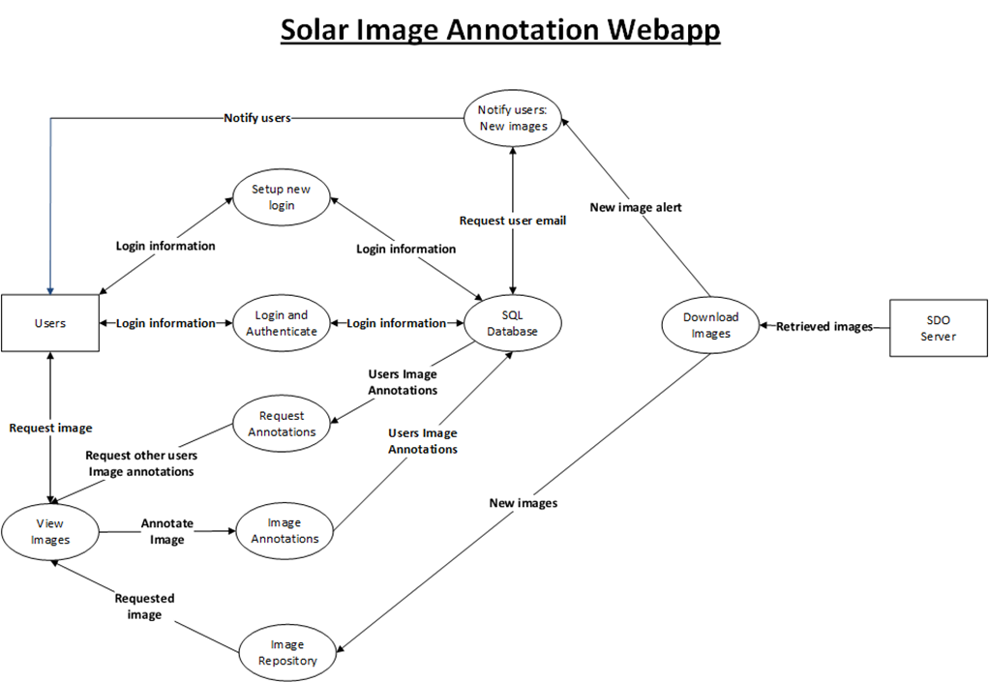
Data Flow Diagram

Appendix D: Use Case Diagram
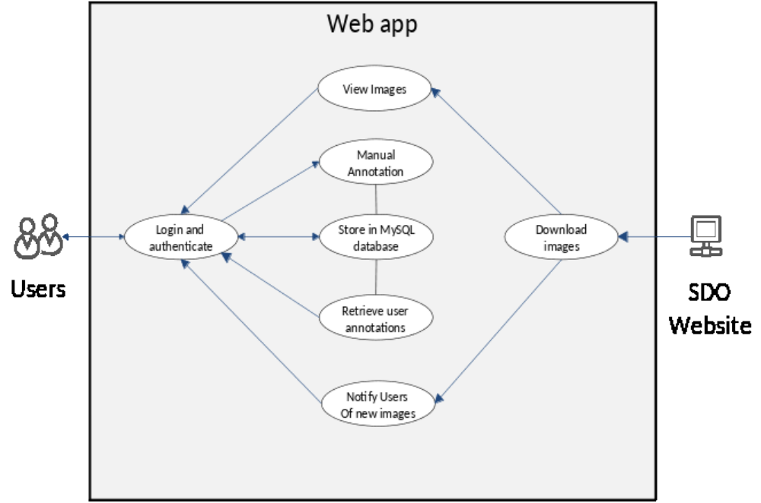
Use Case Diagram

Appendix E: Dashboard GUI View
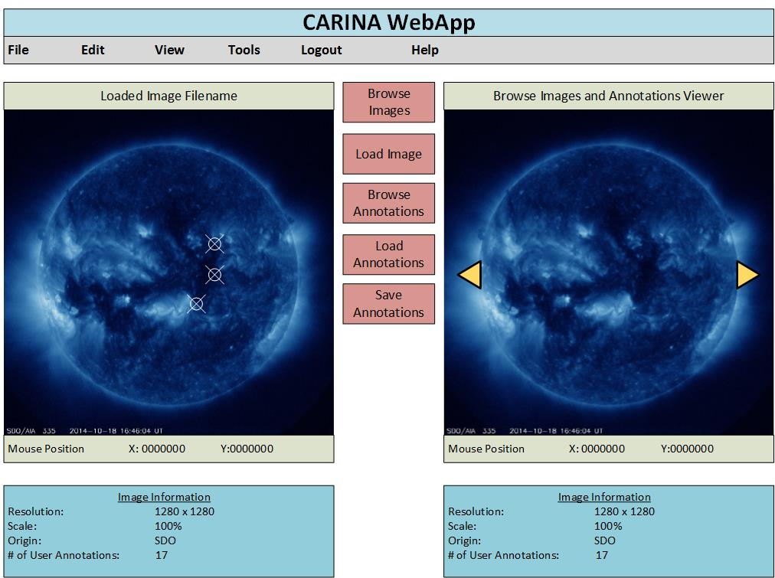
Dashboard GUI View
Appendix F: Subsystem Decomposition Diagram
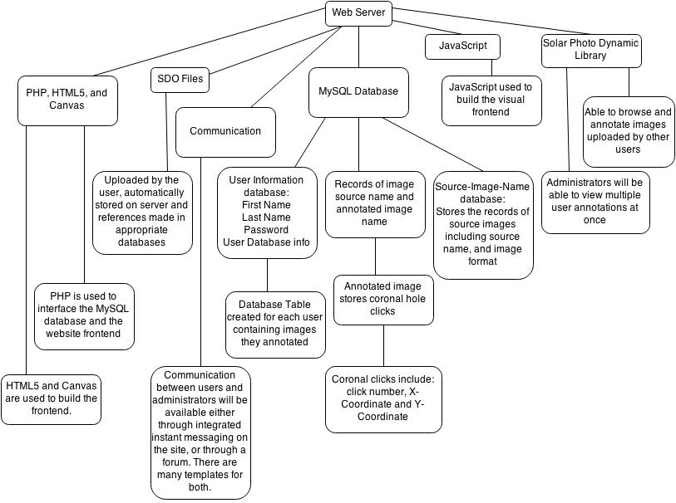
Subsystem Decomposition Diagram
Appendix G: Database Entity-Relationship Diagram
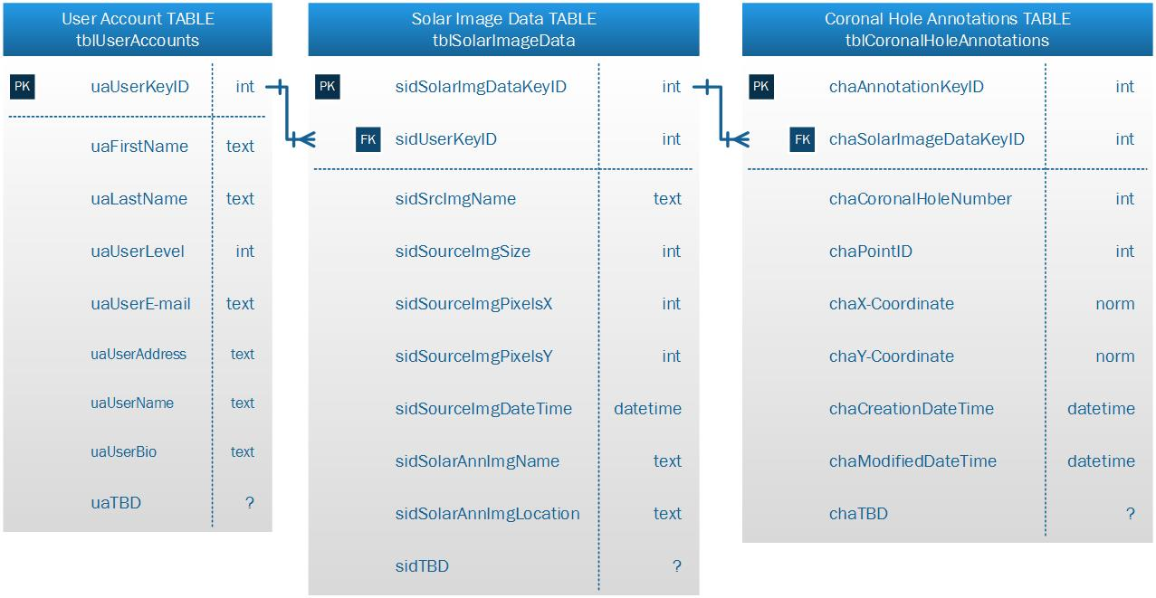
Database Entity-Relationship Diagram

